Careers and Employability Fair

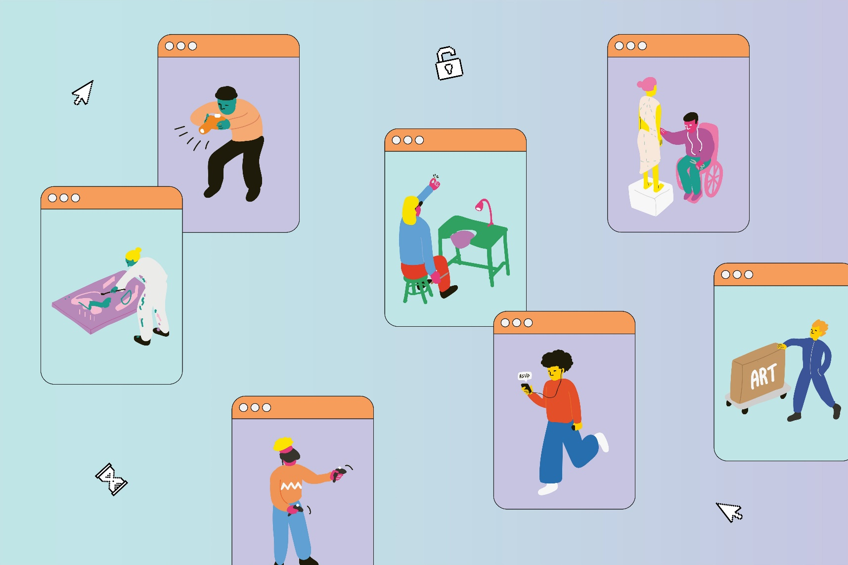

Wednesday 22 October 2025  
11.30am-3.30pm

Central Saint Martins, Granary Building, 1 Granary Square, London N1C 4AA

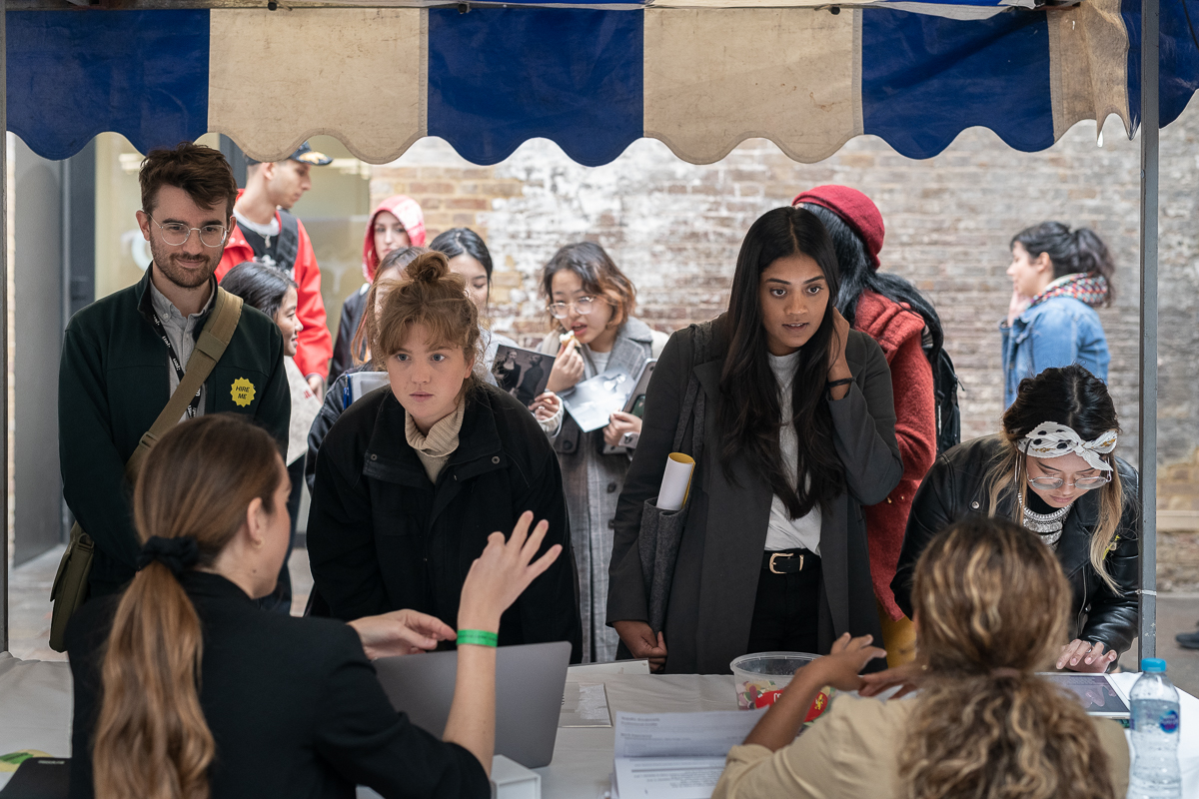

**Contents**

|  |  |
| --- | --- |
| * **Introduction** | **3** |
| * **Why get involved?** | **4** |
| * **How to get involved** | **5** |
| * **Our audience** | **6** |
| * **Previous employers** | **7** |
| * **Criteria for involvement** | **8** |
| * **What next** | **8** |
| * **Key contacts** | **8** |

Introduction  
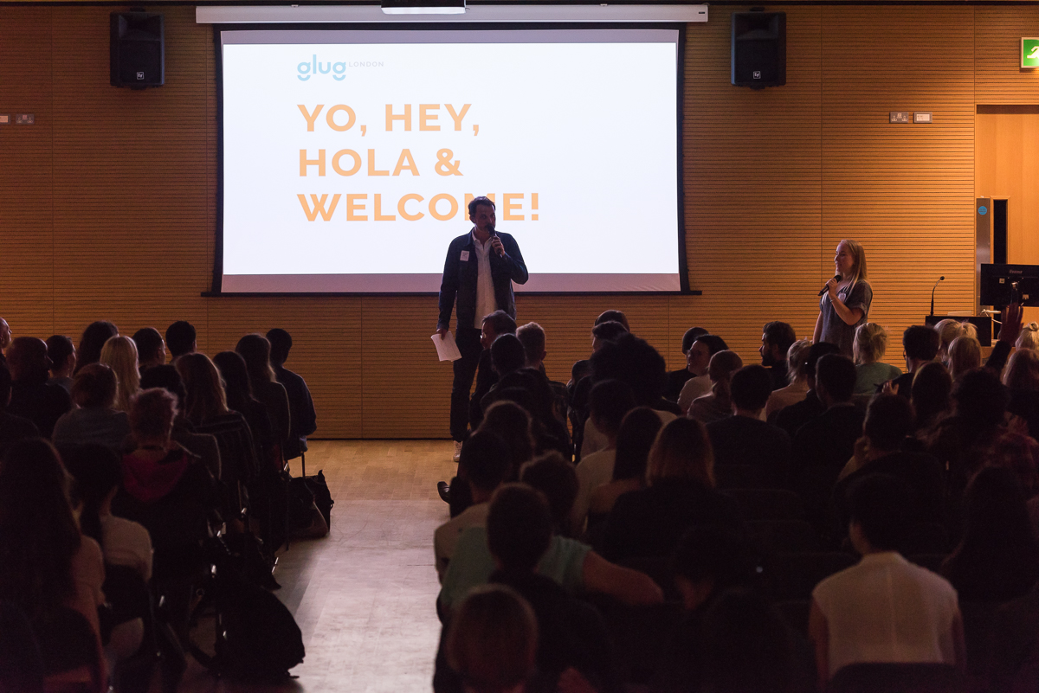**Our fair is run in partnership with** [**Creative Opportunities**](https://creativeopportunities.arts.ac.uk/)**,** University of the Arts London’s (UAL’s) industry jobs and opportunities site for students and graduates. Run by UAL’s Careers and Employability team, it’s the go-to jobs board for art, design, communications, and performance graduates.

Our careers and recruitment event, **Careers and Employability Fair**, will take place on **Wednesday 22 October 2025** atCentral Saint Martins, Kings Cross, London N1C 4AA**.** Your organisation will get the opportunity to interact with UAL students and graduates engaging with a variety of advice, support and information about work opportunities and finding work. So, whether you are actively recruiting or have careers-related advice to share about job hunting or future opportunities, we’d love for you to be part of our event.

This event is a great opportunity for you to engage with University of the Arts London’s (UAL’s) world-class creative students and graduates and promote your brand and vacancies across our [6 renowned colleges](https://www.arts.ac.uk/colleges).

UAL has over 20,000 creative students on the cutting edge of cultural life in London, along with over 160,000 graduates. From our first-year students looking for part time work to support their studies, to our recent graduates looking to enter the workforce in full time creative roles, your organisation is certain to make meaningful connections with potential candidates.

Attendees are provided with opportunities to:

* Find out about relevant vacancies with the opportunity to apply.
* Gain a greater understanding of working and career paths within the creative industries.
* Get tailored, individual advice.
* Connect and network with industry.
* Access and take-up opportunities.
* Signpost and create awareness of the current jobs market.
* Increase understanding of the skills and attributes required to find work.

# Why get involved?

The Careers and Employability Fair offers you the opportunity to get your brand and services in front of the next generation of creative talent and meet students and graduates face to face.

**Benefits of being involved**

Employers who take part in the Careers and Employability Fair can expect a supportive and engaged audience of creative students and graduates from Europe’s leading Arts University (ranked #2 in the world for art and design education).

UAL is made up of 6 leading arts colleges: Camberwell College of Arts, Central Saint Martins, Chelsea College of Arts, London College of Communication, London College of Fashion and Wimbledon College of Art. Renowned names in the cultural and creative sectors produced by the University include:

* Over half of all Turner Prize winners and nominees since its inception.
* 37 of the 80 Royal Academicians - a further 17 are serving or former staff.
* Over half of the recipients of British Designer of the Year.
* 10 current Royal Designers for Industry for product or industrial design.
* Over half of the fashion designers that show at London Fashion Week.
* Multiple winners in the most prestigious art and design awards: from the BP Portrait Award; Jerwood Prize; Taylor Wessing Photographic Portrait Prize; Minerva Medal; BAFTAs, Golden Globes and Oscars.

With the additional benefit of association with University of the Arts London, the Careers and Employability Fair offers the opportunity to engage with the University’s vast network including more than **160,000** alumni, **20,000** students.

## Careers and Employability Fair benefits include:

* Stand at the event and in event guide.
* Feature in the Careers and Employability Fair Social campaign to promote your company and roles (98,000+ combined social media followers).
* Newsletter/email campaign (14,000+ recipients).
* Talking directly to a captive and relevant audience.
* Exclusive opportunity to access and review our students and graduates’ CV’s and portfolios.

# How to get involved

You can get involved with Careers and Employability Fair in the following ways:

1. **Employer / Employability Support** **stand**

Having a stand at our Careers and Employability Fair gives employers and employability support organisations the opportunity to engage directly with our students and graduates.

The employer stand package includes:

* A 7ft stand.
* Refreshments available for 2 representatives throughout the day.
* Free WIFI internet access for laptops and handheld devices (tablets etc).
* Employer listing in Career Fair digital guide.
* Instagram feature on our Instagram stories and reach our active audience of job seeking creatives.

**Please see the below table for pricing including concessions and early bird discounts.**

1. **Offer one-to-one CV or portfolio advice**   **£20 discount**

If you have experience of hiring for creative roles and/or can offer advice about how to best communicate experience; what you should or shouldn’t include in a CV or portfolio; and tips for presenting and formatting, we’d love you to be involved.

One-to-one online advice sessions will be in person during the fair, last for 15-minutes (with a 5-minute break in between). We request just 2-hours (6 advice sessions) of your time. You are welcome to do more if you want!

In return for your time, we can give you a £20 discount off the cost of your stand.

**PRICE BREAKDOWN**

|  |  |
| --- | --- |
| Early bird special - 2 hour one-to-one CV/portfolio advice session and employer/employability support stand (request received by 31 July) | £60.00 |
| Early bird special - employer/employability support stand (request received by 31 July) | £80.00 |
| 2 hour one-to-one CV/portfolio advice session and employer/employability support stand (request received after 31 July) | £80.00 |
| Employer/employability support stand (request received after 31 July) | £100.00 |
| Provide own stand | £150.00 |
| Electricity for stand (limited spaces available) | £20.00 |
| CONCESSIONS - Free stand for charities, social enterprises or UAL Alumni | £0.00 |

# Our audience

**Careers and Employability Fair is open to all UAL students and alumni.**

**Statistics about UAL population**

* UAL students: 22,000+ students from 130+ countries,
* Courses available: 100+ undergraduate, 90+ postgraduate, 1,600+ short courses,
* Course discipline variety:
* 3D design and product design
* Accessories, footwear and jewellery
* Animation, interaction, film and sound
* Architecture and spatial design
* Fashion business and management, and science
* Communication and graphic design
* Creative computing
* Curation and culture
* Fashion design
* Fine art
* Illustration
* Journalism, PR, marketing, media and publishing
* Photography
* Textiles and materials
* Theatre, screen and performance

**Creative Opportunities Job Fair 2024-2025**

* 29 stands, 1897 bookings, 1,200 attendees
* student status: 67% current student, 30% alumni/graduate, 3% other/unknown
* college attendees: 9% Camberwell, 25% Central Saint Martins, 7% Chelsea, 29% London College of Communication, 22% London College of Fashion, 2% Wimbledon, 3% Creative Computing Institute; 3% other

**Creative Opportunities**

* vacancies are seen by the largest pool of creative candidates in the UK.
* advertises up to 125 new graduate vacancies and internships per month.
* receives 1.3 million+ page views every year.

**Careers and Employability social media**

* Combined following of 113,000+ across Instagram our newsletter Facebook and LinkedIn and The Dots.

# Previous Employers

*We are looking for employers and partners that reflect the diversity of our student body through their EDI practices and policies.*

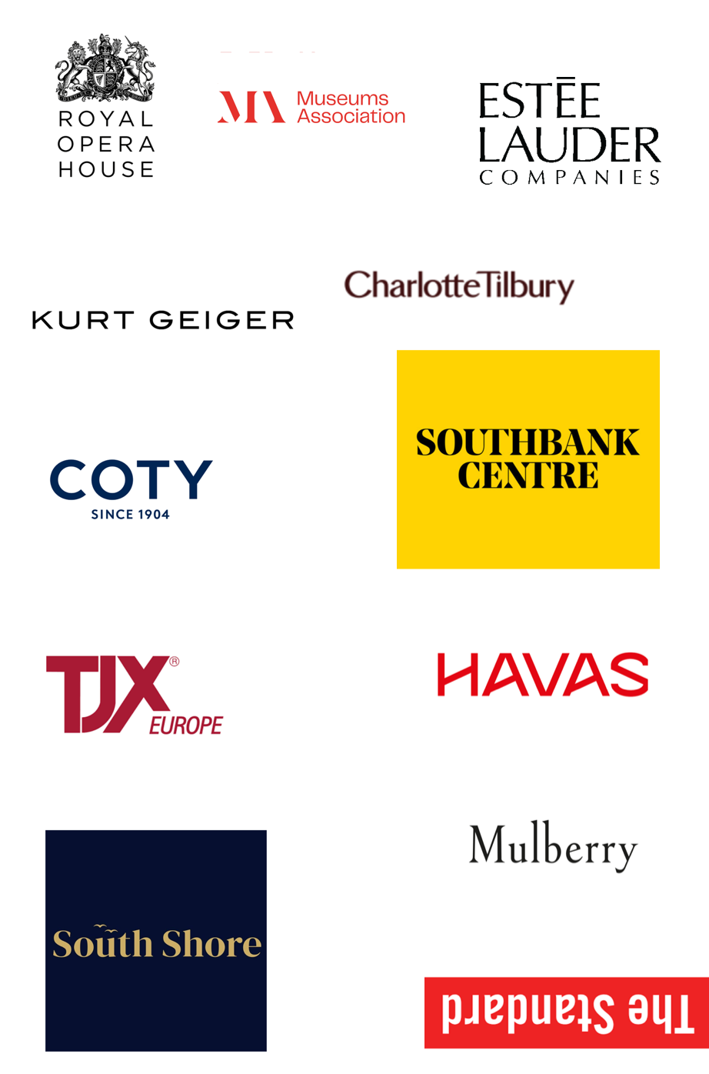

# Criteria for involvement

* Taking part in the Careers and Employability Fair is open to; employers actively recruiting for open vacancies and yearly internship / graduate schemes; recruitment agencies, jobs boards or apps; and companies or platforms directly supporting employment and employability.
* All jobs on offer must meet government [minimum wage](https://www.gov.uk/national-minimum-wage-rates) rates. We recommend London-based employers to pay the [London Living Wage](https://www.livingwage.org.uk/calculation) and wider UK employers to offer the UK living wage. (As of 2025, NMW £12.21 ph and UKLW £12.60 ph and LLW £13.85 ph)
* We will only promote opportunities that align with UAL values and are of an appropriate nature for our students and/or graduates.
* All internships must meet government [minimum wage](https://www.gov.uk/national-minimum-wage-rates) rates. We do not promote unpaid internships. Internship roles require a named supervisor to show that the intern has a mentor and learning support.
* We promote volunteering roles which focus on creative roles and sectors leading to graduate level experience, allowing for **genuine career progression**.  These roles must come from UK-based charities registered with the UK Charity Commission, or not-for-profit organisations, associated fundraising bodies, a statutory body or voluntary organisations from the third sector.
* We will not advertise companies or roles where the candidate must pay a cost to apply or are required to invest in the role.
* All employers and roles must be in line with [Creative Opportunities policies](https://creativeopportunities.arts.ac.uk/employer-tcs/).

# What next?

To be part of this exciting opportunity please complete our [booking request form](https://forms.arts.ac.uk/creative-opportunities-unlocked-career-fair-booking-request-form/)

**Please note that we will require the following information from you once your booking is accepted:**

* Company logo.
* Short company biography.
* Links to your social media channels.

…………………………………………………………………………………………………………………

# Key contacts

Event Manager: Leila Hill, Events and Showcasing Coordinator, Careers and Employability

Event Marketing: Alice Walker-Mitchell, Marketing and Digital Projects Manager

Email: [careersevents@arts.ac.uk](mailto:careersevents@arts.ac.uk) 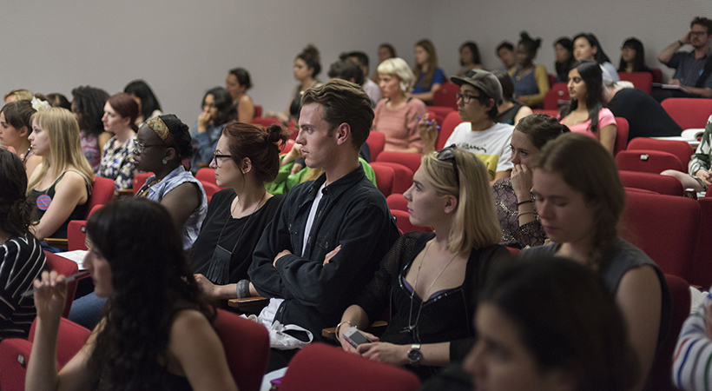Instagram: [careers_employability](https://www.instagram.com/careers_employability/)

LinkedIn: [ualcareers](https://www.linkedin.com/in/ualcareers/) The Dots: [University of the Arts London](https://the-dots.com/pages/university-of-the-arts-london-ual-71207)

[**arts.ac.uk/students/student-careers/find-jobs-and-internships/student-graduate-job-fair**](https://www.arts.ac.uk/students/student-careers/find-jobs-and-internships-on-creative-opportunities/student-graduate-job-fair)